**TOURS AND TRAVEL MANAGEMENT SYSTEM**

**TAIFA FEIZEL WAMBANI**

**EDST1/07438/22**

**SUPERVISOR: LUKE MWEMA**

**A Project Report submitted to the Faculty of Physical sciences, engineering and technology in partial fulfilment of the requirements for the award of Diploma in Computer Science of Tharaka University**

**November, 2023**

# DECLARATION

I hereby declare that this project is based on my original work except for citations and quotations which have been duly acknowledged. I also declare that that it has not been previously and concurrently submitted for a degree or any other award in any other educational institution

Student Name:

………………………………………….

Signature:

………………………………………….

Date:

………………………………………….

**APPROVAL**

This project was conducted under our supervision and is submitted with our approval as university supervisor.

Supervisor Name: ………………..

Signature: …………………

Date: ……………………

# DEDICATION

I dedicate this project to my parents and Mr. Francis who has helped me in working out the project.

# ACKNOWLEDGEMENTS

I first thank the almighty God and secondly, I thank Mr. Francis for giving advices on the projects and correcting mistakes made in the project and thus the project being successful.

# ABSTRACT

Tours and Travel Management System is designed to revolutionize the way travel agencies and companies handle their operations and cater to their clients' needs. The tourism industry has experienced significant growth in recent years, leading to increased demand for efficient and seamless travel services. Tours and Travel Management System offers a cutting-edge platform that streamlines various aspects of tour management, such as itinerary planning, bookings, reservations, customer management, financial transactions, and reporting. The primary objective of Tours and Travel Management System is to enhance the efficiency and automation of tour management processes, reducing manual efforts and minimizing errors. By offering an interface that is user-friendly, Customers can easily view available travel packages, make bookings, and access real-time travel information, making a smooth booking experience. One of the key benefits of Tours and Travel Management System is resource optimization. Travel agencies can effectively manage their time, staff, and finances, leading to improved productivity and cost-effectiveness. Furthermore, the system focuses on providing exceptional customer satisfaction by offering personalized itineraries, quick response times, and efficient communication channels. Data management and analysis capabilities are in Tours and Travel Management System thus allowing travel agencies to gain valuable insights into customer preferences, market trends, and how they are performing This enables them to make data-driven decisions, enhancing their services and offerings.

The significance of Tours and Travel Management System lies in its potential to advance the tours and travel industry by embracing technology, promoting healthy competition, and promoting innovation. With the implementation of Taifa Tours, travel agencies can expect business growth, an enhanced customer experience, and streamlined operations. In conclusion, Tours and Travel Management System represents a game changing solution for the modern tourism industry. By providing efficient automation and exceptional customer satisfaction. Taifa Tours empowers travel agencies to thrive in a dynamic and competitive market, shaping the future of the industry as a whole.

In chapter four and five presented is a comprehensive web-based solution developed using JavaScript, bootstrap, PHP, Sql, CSS, html, and MySQL. The system comprises a visually appealing front-end built on the Savory theme, accompanied by a secure back-end accessible only to administrators. Implementation and testing were conducted using xampp control panel and various browsers, ensuring user-friendly interfaces and seamless integration of components. The system's functionality was assessed through user testing, integration checks, and compatibility testing across multiple browsers, all yielding positive outcomes. The system's structure encompasses sections such as 'About Us,' 'Destinations,' 'Contact Us,' 'Latest Deals,' and 'Book Tours.' While limitations were encountered during development, including technical challenges and time constraints, the system stands as a transformative solution in the travel and tourism sector. Future recommendations focus on expanding functionalities, enhancing user interaction, integrating promotional details, diverse payment options, and improving overall system resilience to meet evolving industry needs.

Top of Form

# TABLE OF CONTENTS

Contents

DECLARATION i

DEDICATION ii

ACKNOWLEDGEMENTS iii

ABSTRACT iv

TABLE OF CONTENTS v

CHAPTER ONE: INTRODUCTION 1

1.0 Introduction 1

1.2 Problem Statement 2

1.3. Objective 2

1.3.1 General Objective 2

1.3.2 Specific Objective 2

1.4 Research Questions. 2

1.5 Significance of Study 3

1.7 Scope 3

CHAPTER TWO: LITERATURE REVIEW 4

2.0 Introduction 4

2.1 Review of the Related Work 4

2.2 Conclusion 5

2.3 CONCEPTUAL FRAMEWORK 6

CHAPTER THREE: METHODOLOGY 7

3.0 Introduction 7

3.1 System Design 7

3.2 System Methodology 7

3.5.1 Questionnaire 8

3.5.2. Interview 8

3.5.3 Observation 8

3.6 Data Analysis 8

3.7 System Analysis 9

CHAPTER FOUR: FINDINGS, IMPLEMENTATION, TESTING AND RESULTS 10

4.1 IMPLEMENTATION 10

4.1.1Hardware/Software Interface 10

4.1.2 IMPLEMENTATION LANGUAGES 10

4.2 Testing 10

4.2.1 User Testing 10

4.2.2 Integration Testing 10

4.2.3 Compatibility Testing 10

4.3 Results 11

4.3.1.1 Homepage 11

4.3.1.2 About us 13

4.3.1.3 Destination page 14

4.3.1.4 Contact us 15

4.3.1.5 Latest Deals page . 16

4.3.1.6 Book Tours 17

CHAPTER FIVE: SUMMARY, CONCLUSION AND RECOMMENDATION 19

5.1 Objective 19

5.1.1 Create a centralized database and integration framework. 19

5.1.2 Implement user-friendly comparison tools. 19

5.1.3 Establish a communication platform for real-time updates 19

5.1.4 Design an intuitive trip planning interface 19

5.2 Future Recommendations 19

5.2.1 Future Projects 19

5.3 Limitation 19

5.4 Conclusion 19

Appendix I 21

Appendix II 22

Appendix III 23

# CHAPTER ONE: INTRODUCTION

# 1.0 Introduction

The purpose of this project Tours and Travel Management System is to manage Tours and Travel events Properly. Tours and Travel Management System is a system used to book a tour from anywhere in the world by a single website which will help the user to know all about the place and tour details.

**1.1 Background of the Study**

The travel industry has grown over the years, driven by factors such as increasing disposable incomes, globalization, improved transportation infrastructure, and a growing interest in leisure and business travel. This growth has led to a higher demand for efficient travel management solutions. Also travel agencies and tour operators relied on manual processes for booking flights, hotels, tours, and other travel-related services. These manual processes were time-consuming, error-prone, and limited the ability to provide real-time information to customers.

The advancement of technology, the travel industry has embraced various digital tools and online platforms to cater to the needs of modern travelers. Tours and Travel Management System is a response to these technological advancements and provides a centralized platform to manage all travel-related activities. In today's fast-paced world, travelers expect convenience, instant access to information, and personalized services. A strong management system allows travel businesses to meet these expectations and enhance customer satisfaction.

The travel industry is highly competitive, with numerous travel agencies and online booking platforms vying for customers' attention. To stay competitive, travel businesses need to adopt efficient systems that improve their operational efficiency and offer better customer experiences. Tours and Travel Management System generates a vast amount of data related to customer preferences, booking patterns, popular destinations, etc. Analyzing this data can help businesses make informed decisions, optimize offerings, and target specific customer segments more effectively. The system integrates with various travel suppliers such as airlines, hotels, car rental companies, and tour operators. This integration facilitates seamless booking processes and real-time availability of services. The travel industry deals with sensitive customer information, including personal details and payment data. Therefore, ensuring the security and privacy of this data is of paramount importance in the design and implementation of a travel management system. Travel businesses must comply with various industry regulations and standards. The management system should adhere to these requirements, ensuring legal and ethical practices.

# Problem Statement

Disconnected data in the existing system, essential travel components such as flight details, accommodations, and activity bookings are stored in separate databases or systems.

Customers engaging with the current system face difficulties in efficiently comparing different travel options.

Ineffective communication channels and processes between travel agencies, service providers, and customers contribute to misunderstandings and disruptions.

The absence of real-time updates for travelers about changes in their travel itineraries, flight delays, or other critical information impacts their experience.

The management of sensitive customer data and payment information lacks comprehensive security measures.

1.3. Objective

1.3.1 General Objective

The general objective was to design and develop a fully functional Tours and Travel Management System

1.3.2 Specific Objective

1. Create a centralized database and integration framework to consolidate travel information, ensuring a seamless and comprehensive view of itineraries and bookings.
2. Implement user-friendly comparison tools that allow customers to easily compare travel options, including prices, services, and features, facilitating informed decision-making.
3. Establish a communication platform for real-time updates, notifications, and interactions among travel agencies, service providers, and customers to minimize misunderstandings and disruptions.
4. Design an intuitive trip planning interface that enables effortless arrangement of multi-destination trips or group tours, minimizing complexity and errors.

# 1.4 Research Questions.

1. How can a centralized database and integration framework be developed to consolidate diverse travel information from multiple sources?
2. What user interface design principles and interaction models contribute to the development of effective and user-friendly travel option comparison tools?
3. How can personalized communication channels be integrated to cater to different communication preferences and needs of travelers?
4. What user experience design elements contribute to the development of an intuitive and efficient trip planning interface for multi-destination or group tours?

# 1.5 Significance of Study

The development of Tours and Travel Management System can contribute to the advancement of the tours and travel industry by embracing technology and best practices encouraging competition, and innovation. Tours and Travel Management System can empower travel agencies to expand their customer base, offer tailored experiences, and penetrate new markets, thus fostering business growth.

With seamless booking processes and personalized services, travelers are likely to have a more enjoyable and memorable travel experience, leading to increased customer loyalty and positive compliments. By automating various tasks, such as reservations, payment processing, and tour scheduling, Taifa Tours can help travel agencies optimize their operations and reduce operational costs.

**1.6 Limitations**

Developing and implementing a comprehensive system require a significant initial investment in terms of technology, infrastructure and personnel.

Integrating the new system with existing travel industry standards, third-party APIs, and legacy systems could prove to be complex and time-consuming.

Designing an intuitive and user-friendly interface that caters to diverse user groups with varying levels of technological proficiency can be a challenging task.

Catering to travelers from diverse cultural backgrounds and languages might require extensive localization efforts and language support.

# 1.7 Scope

There is the automated booking and reservation processes for flights, accommodations, transportation, and activities.

There is the creation and customization of travel itineraries, including multi-destination trips and group tours.

User-friendly interfaces for comparing travel options, prices, services, and features.

Real-time communication channels for travelers, travel agencies, and service providers.

# CHAPTER TWO: LITERATURE REVIEW

# 2.0 Introduction

Taifa tours management system is designed to enhance and automate various process involved in the travel and tourism industry. This chapter presents the benefits, challenges and impacts on the industry by reviewing work done by authors.

# 2.1 Review of the Related Work

[2]This study examines the challenges faced by travel agencies in adopting and implementing management systems. The paper highlights the importance of integrating technological solutions to improve efficiency, customer satisfaction and competitiveness. It also discusses opportunities for travel agencies to leverage digital platforms for business growth.

[3]This review explores the use of mobile applications in the travel and tourism industry. It highlights how mobile apps have transformed the way travelers pay their trips, book tours, and access destination-related information. The paper also discusses the benefits o mobile apps for travel agencies in terms of marketing, customer engagement and personalized service delivery.

[4]This study examines the influence of online tourism platforms and systems on tourists decision-making processes. It discusses how travel and tour management systems play a significant role in shaping tourists’ choices regarding destinations, accommodations and activities.

[5]This review explores the utilization of big data analytics in the tourism and hospitality industry. It discusses the potential of big data in travel and tours management systems to capture, analyze and utilize vast amounts of data for customer segmentations, personalized offers, and operational optimization.

[6]This research focuses on online payments systems in the travel industry and their influence on customers’ purchase intentions. The paper highlights the significance of secure payment gateways and their impact on building trust and reducing perceived risks, leading to increased online bookings and customer loyalty.

[7] The literature on the effects of security threats such as terrorism, political instability, and geopolitical power-plays on travel and tourism has produced mixed results with scant attention paid to the spillover effects on the tourism economy (e.g., employment, leisure expenditure, travel, and tourism services’ contribution to gross domestic product).

[1]The travel and tourism industry is seeking to achieve consistently seamless experience for customers to stay connected with brands. This study offers an analysis of the interconnected customer experience journey based on an understanding of multichannel behavior.

[8] Although the transport industry provides the link between tourism generating and destination regions the industry's role as an agent in destination development has been largely overlooked

P

P

# 2.2 Conclusion

The literature review on the travel and tours management system highlights the importance of technology adoption in the travel industry. The integrated frameworks, mobile applications and big data analytics, it highlights how technology can optimize operations, enhance customer experiences, secure payment gateways, efficient data management and user-friendly interfaces emerge as crucial factors in driving success in the highly competitive travel and tourism landscape.

# 2.3 CONCEPTUAL FRAMEWORK

TRAVEL AND TOURS MANAGEMENT SYTEM

CENTRALIZED DATABASE

USER-FRIENDLY COMPARISON TOOLS

TRIP PLANNING INTERFACE

COMMUNICATION PLATFORM

# CHAPTER THREE: METHODOLOGY

# 3.0 Introduction

This chapter focus on the core functionality of the system .it entities on the design of the system and system methodology the target population and a sampled population. methods of collecting data and lastly data analysis.

# 3.1 System Design

The system contains a user-friendly interface for customers to explore and book travel packages easily. It also has a backend interface for travel administrators to manage bookings, and customer information.

The system has a strong database to store and manage information related to customers, bookings, tour packages, destinations, and pricing it has proper data normalization and indexing for efficient data retrieval and storage. It has a booking system that allows customers to check availability, book tours, and make payments securely. It has features like confirmation emails.

It has secure payment gateways to facilitate online payments, allowing customers to pay for tours using various methods. The system manages tour packages, including pricing, inclusions, and availability and it also allows for customization options to cater to individual preferences. The system manages customer profiles, preferences, and communication history for personalized services It also offers targeted promotions and loyalty programs.

The system is designed to manage travel resources like hotel rooms, transportation, tour guides, and tickets. This helps to ensure efficient allocation and utilization of resources based on demand and availability.

# 3.2 System Methodology

This first process involves understanding the client's needs, preferences, and budget constraints. The system interacts with the client to gather essential information such as travel dates, destinations, activities of interest, accommodation preferences, and any specific requirements. Based on the gathered requirements, the travel agency conducts thorough research to identify suitable travel options. This includes finding appropriate travel routes, accommodations, activities, transportation options, and any special considerations for the destination.

Using the information gathered and researched, the travel agency creates a detailed itinerary that outlines the day-by-day schedule of the trip. The itinerary includes information on sightseeing tours, activities, dining options, and leisure time, ensuring a well-balanced and enjoyable travel experience. Once the travel detail is approved by the client, the travel agency proceeds to make all the necessary bookings and reservations. This includes flights, accommodations, transportation (e.g., buses, trains, or private transfers), and any tickets or passes required for attractions and activities.

Tours and Travel Management System will have a quality assurance process in place to ensure that all services and accommodations meet the expected standards. This may involve checking the reputation and reviews of various service providers to ensure customer satisfaction. Comprehensive documentation is prepared for the traveler, including booking confirmations, travel insurance details, emergency contact information, and other essential documents. Effective communication with the traveler is maintained to address any queries or concerns. During the trip, customer support is provided to address any unforeseen issues or emergencies that the traveler may encounter. A helpline or dedicated customer support team is available to assist travelers as needed.

After the trip, feedback from the traveler is collected to evaluate the overall experience and identify areas for improvement. This feedback helps the travel agency enhance its services and address any shortcomings in future tours. Tours and Travel Management System adheres to legal and regulatory requirements, including safety standards, data protection, and travel-specific regulations in different countries.

**3.3 Target Population**

The target population is mostly the leisure travelers the individual or families seeking vacation packages, holiday tours, adventure trips or relaxation getaways and soon international travelers.

**3.4 Sampling Design**

The sampling design used is random sampling randomly selecting travelers from the entire target population. this is done using random email surveys or selections from customer databases.

**3.5 Data Collection techniques**

3.5.1 Questionnaire

The data collection method to be used is Questionnaire method they are structured sets of question distributed to group of travelers to collect standardized data. They can be administered online, email, or as printed forms. They help in gathering quantitative data, identifying patterns, and comparing responses. This helps in collecting feedback from large number of people.

# 3.5.2. Interview

Involve direct interaction between the interviewer and interviewee who in this case I the tour operator and the traveler.

# 3.5.3 Observation

Involves observing travelers during their trips it provides insights to their behaviors, interactions and experiences.

# 3.6 Data Analysis

The method to be used in data analysis is customer segmentation cluster analysis can be applied to group customers with similar characteristics or preferences.it helps in tailoring tour packages to specific customer segments and designing target market campaigns.

# 3.7 System Analysis

Tours and Travel Management System

Customer

Booking

Department

Individual

Customer

Manager

Corporate Customer

# CHAPTER FOUR: FINDINGS, IMPLEMENTATION, TESTING AND RESULTS

# 4.1 IMPLEMENTATION

The coding for this system is done using simple programming languages which include, JavaScript, bootstrap, PHP, Sql, CSS, html and MySQL. The front-end system is based on savory theme which I have incorporated to make it more appealing to the eye. The system has a front-end and back-end which is only accessible to an administrator. The backend pulls information from the database and displays it for an administrator. The implementation and testing for this project is using xampp control panel and a browser.

# 4.1.1Hardware/Software Interface

This are the minimum hardware and software requirements needed to run the system efficiently. Hardware Interface: • Pentium Processor • 60 MB of free hard-drive space • 128 MB of RAM Software Interface: • Operating System: Windows (7 or above) • Web Browser: IE 10 or above, Mozilla FF 31 and above or Google Chrome.

# 4.1.2 IMPLEMENTATION LANGUAGES

I made use of HTML, PHP, CSS, and Sql. The reasons below illustrate the reasons for my choice of language a) HTML is the standard markup language for creating Web pages. In full it stands for Hyper Text Markup Language.

# 4.2 Testing

# 4.2.1 User Testing

The system was tested by several users randomly selected and gave back positive responses that it was good and they loved how it operated terming it simple and attractive that can be used by many people with ease.

# 4.2.2 Integration Testing

The parts of the system that were connected together were tested including connection of the form in the web page and backend databases and the web pages and styling sheet and results were positive.

# 4.2.3 Compatibility Testing

The system was opened on different web browsers including Microsoft edge, Firefox and google chrome and was found to be compatible with the three without any challenges.

# 4.3 Results

In developing the Tours and Travel Management System, the foundation of our journey lies within the research phase.

**4.3.1 How the System Works**

# 4.3.1.1 Homepage

all users are provided with the home page,

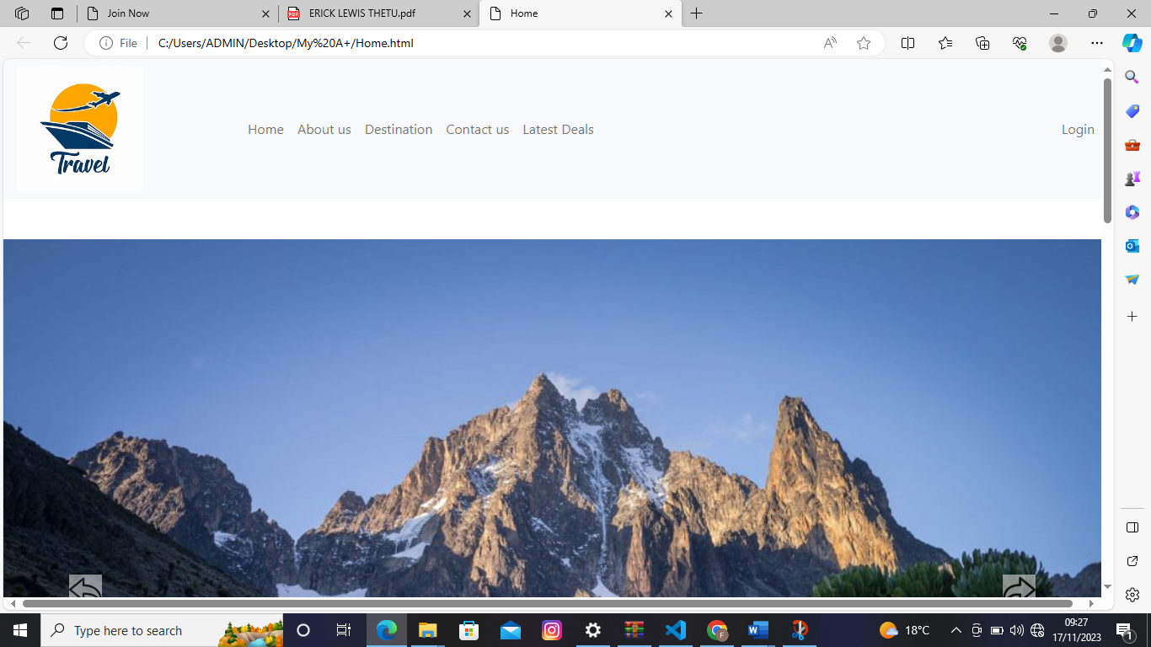

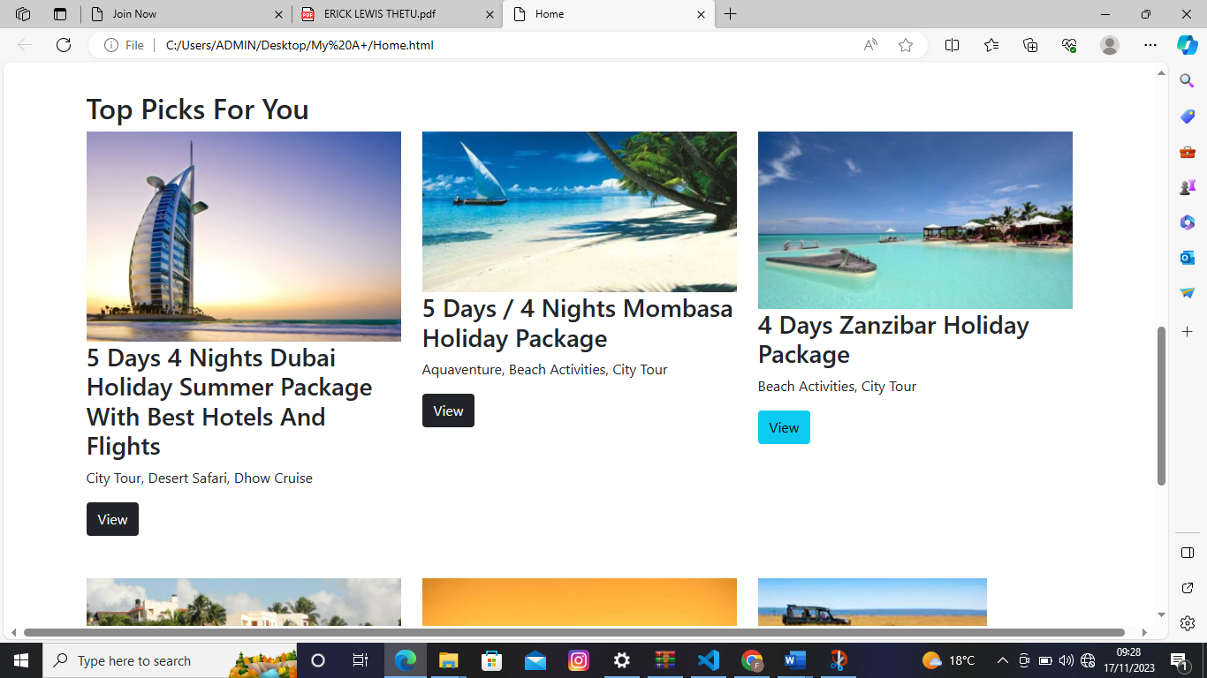

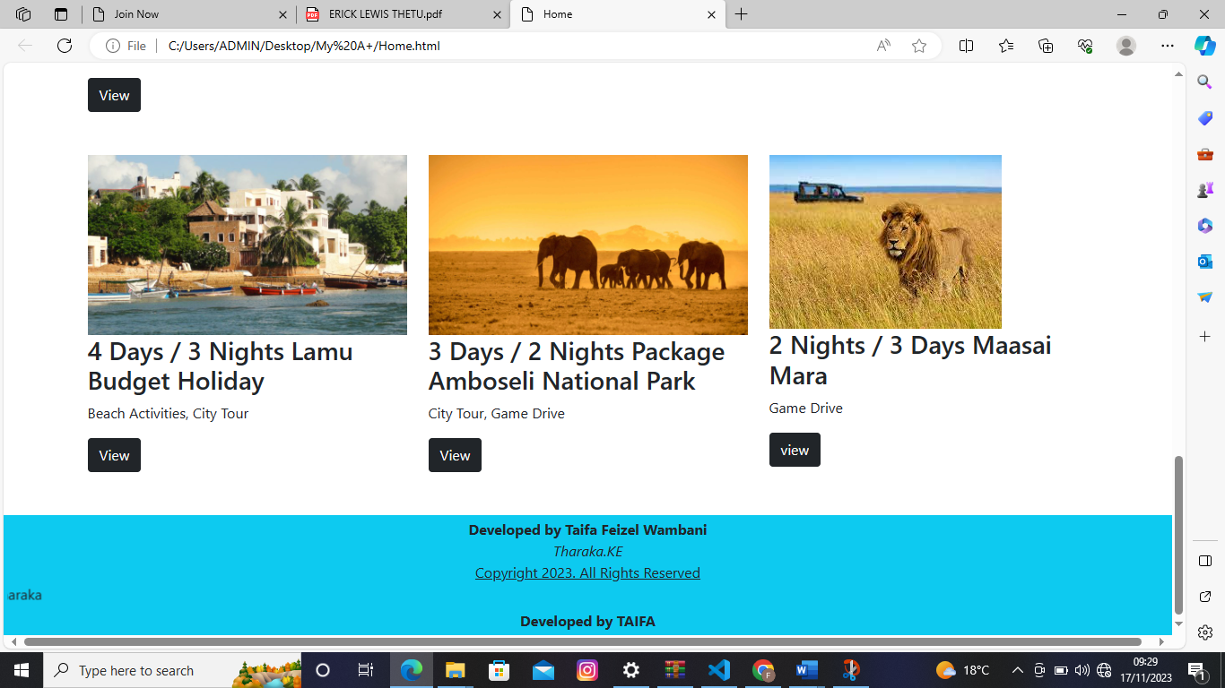

# 4.3.1.2 About us

The About us page contains

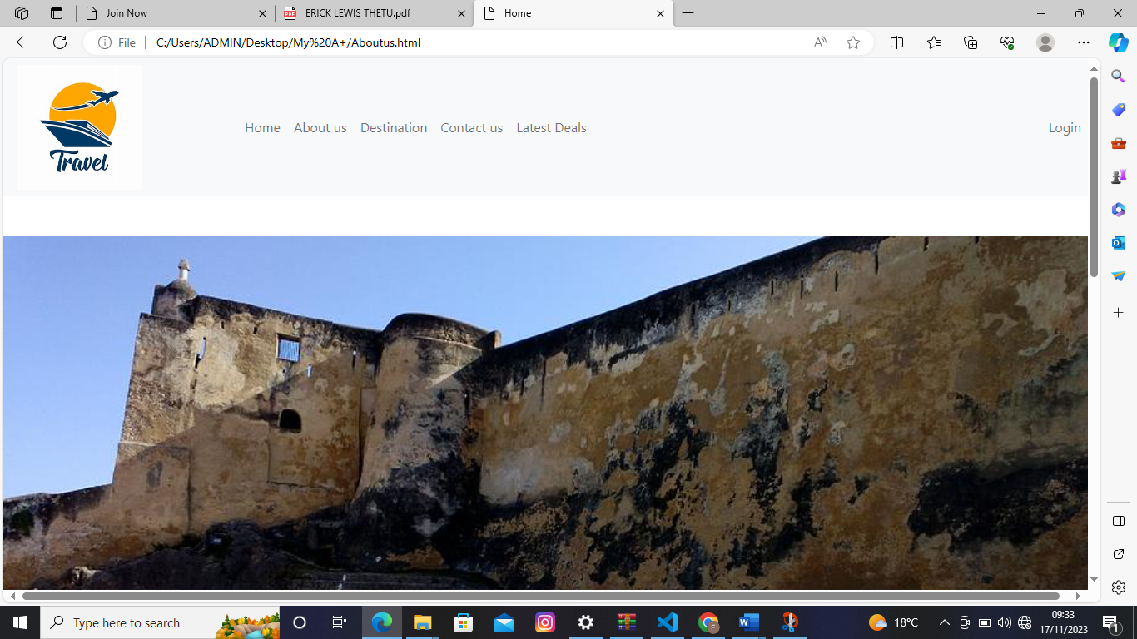

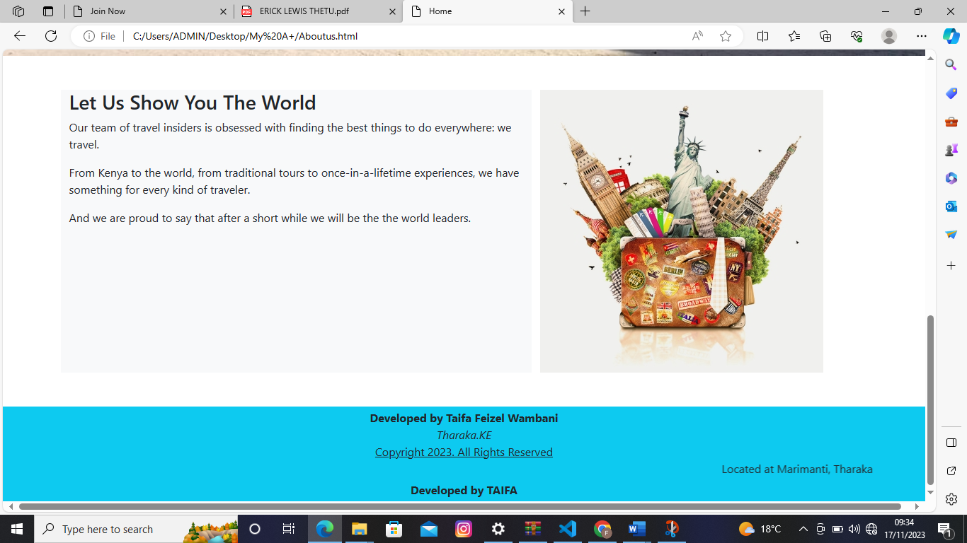

# 4.3.1.3 Destination page

it contains the destinations

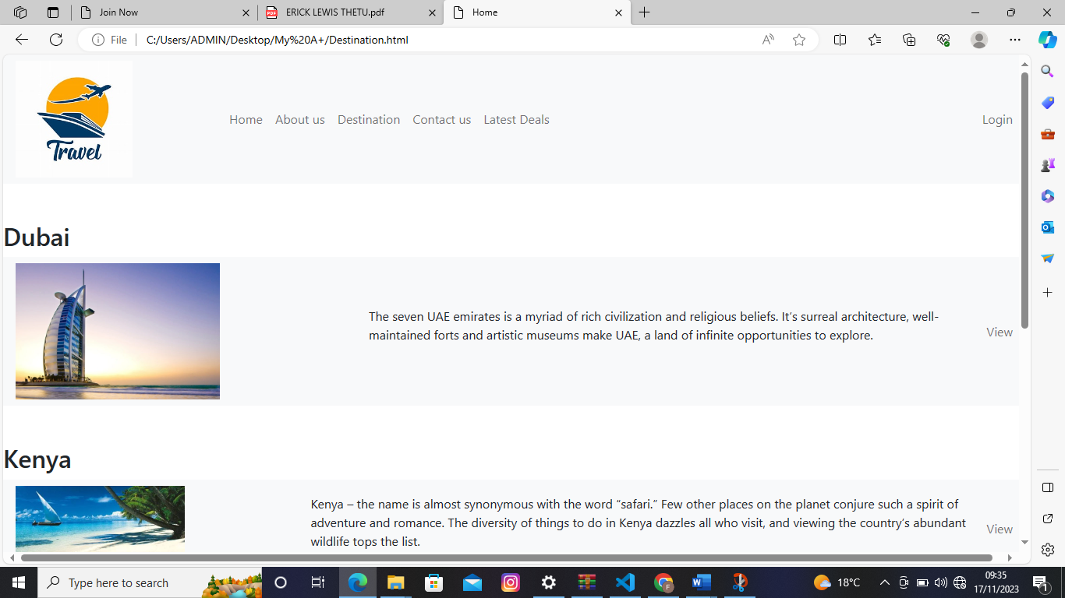

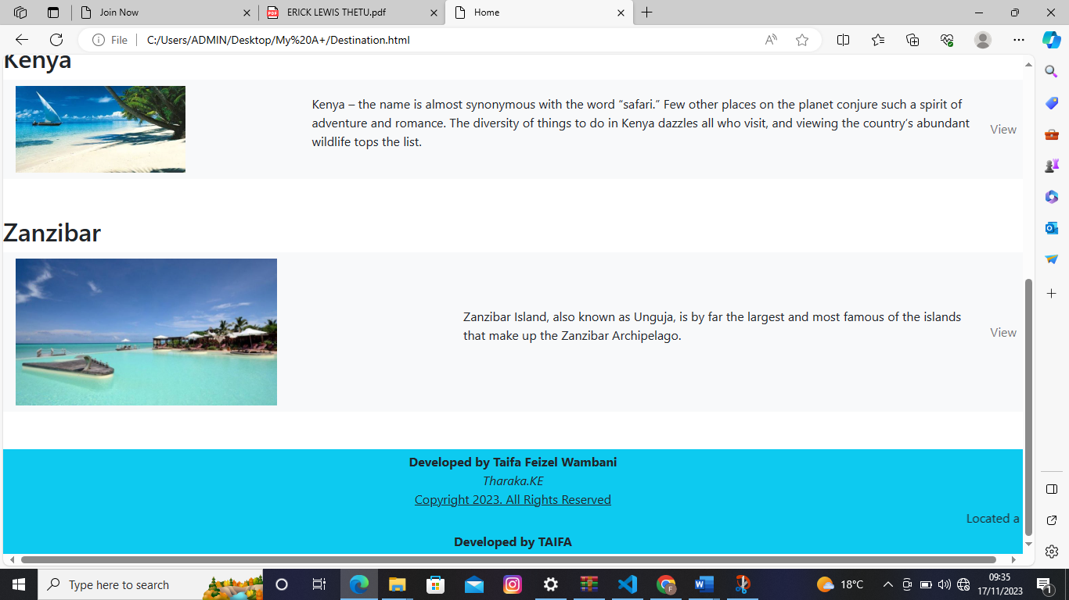

# 4.3.1.4 Contact us

It contains the contacts

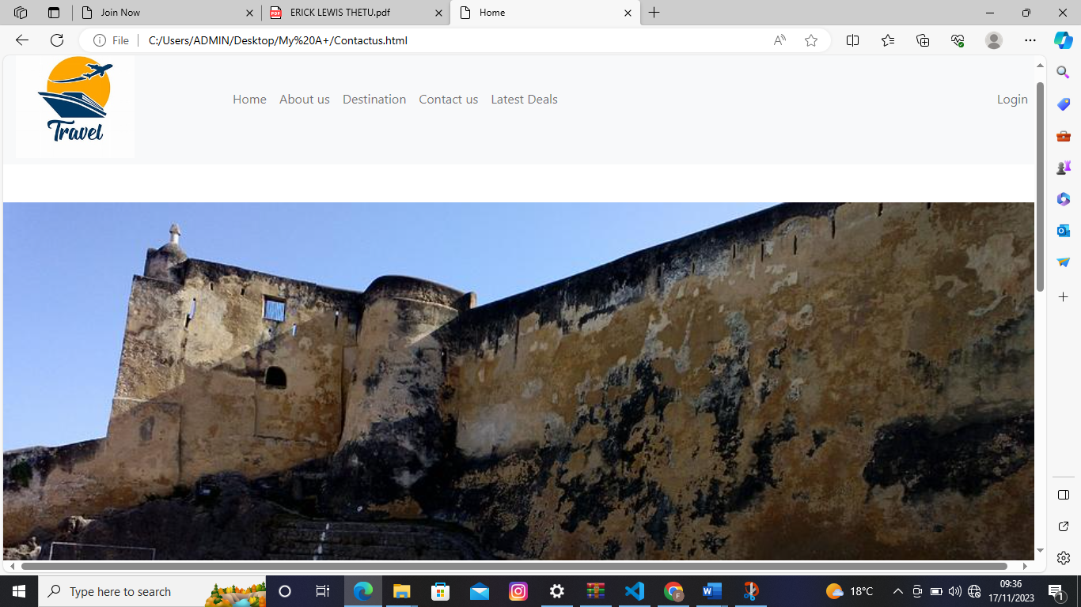

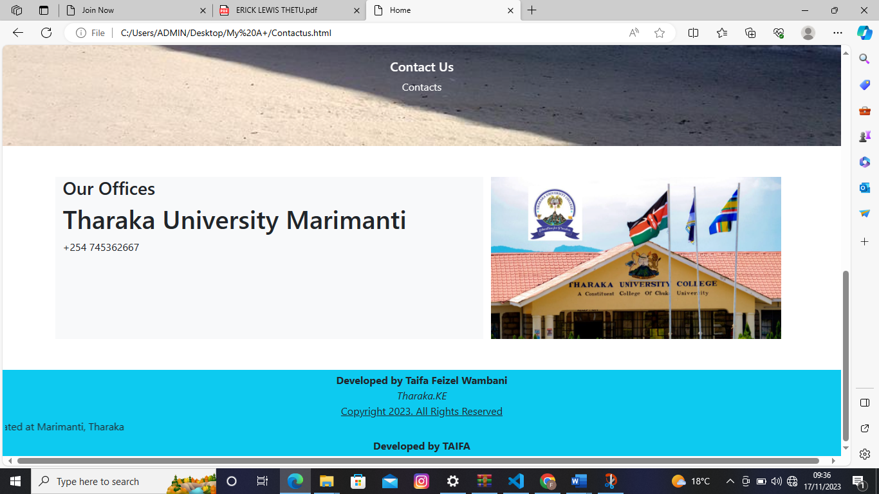

# 4.3.1.5 Latest Deals page .

It contains the latest deals.

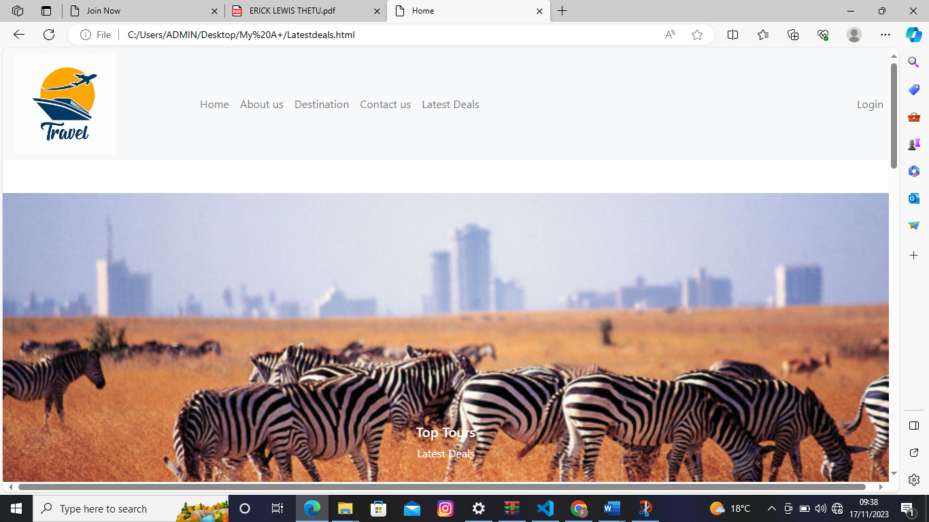

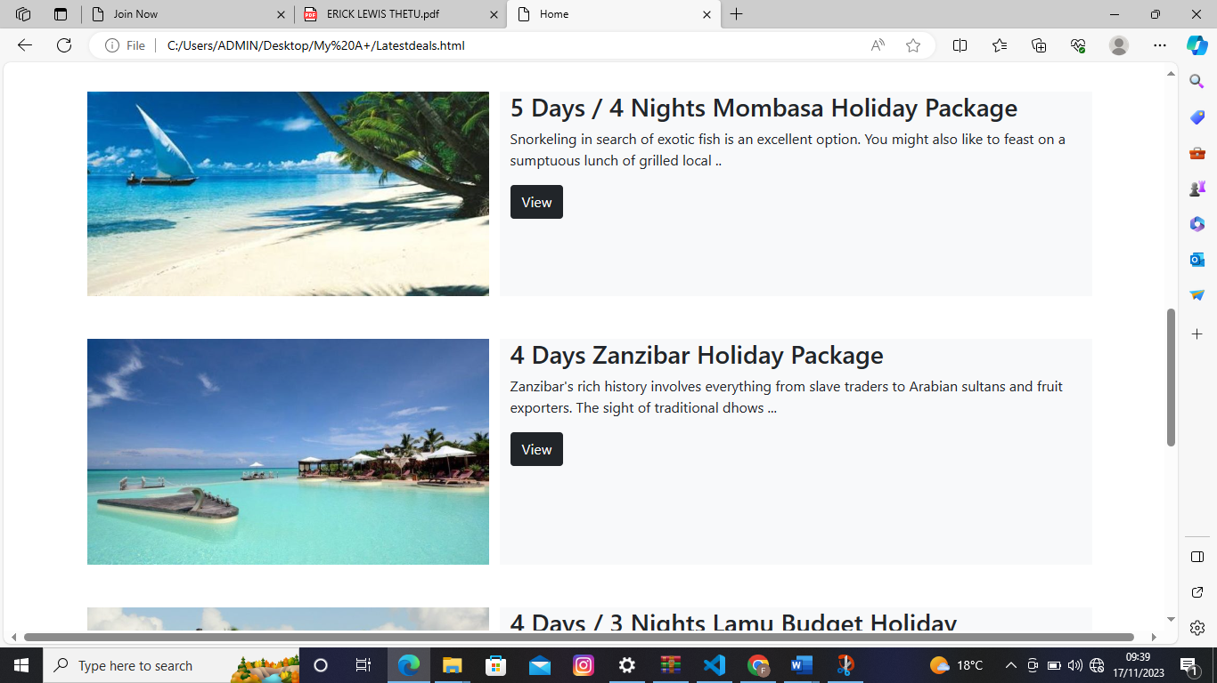

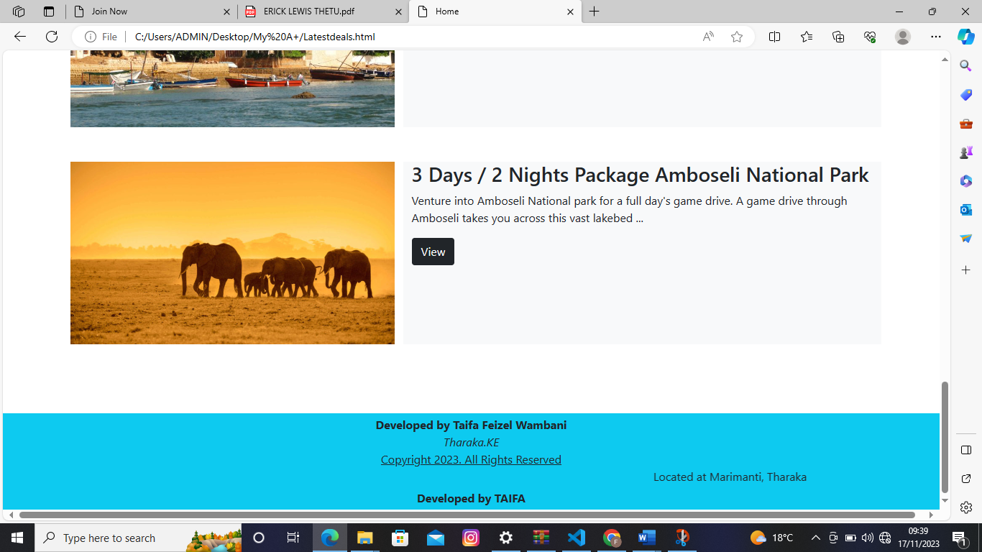

# 4.3.1.6 Book Tours

Though it not shown on the links all the pages are connected to the book page where you book your trip

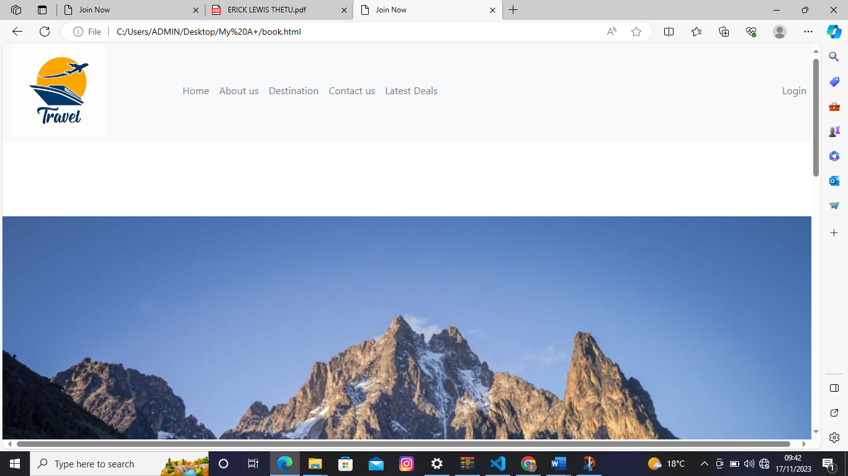

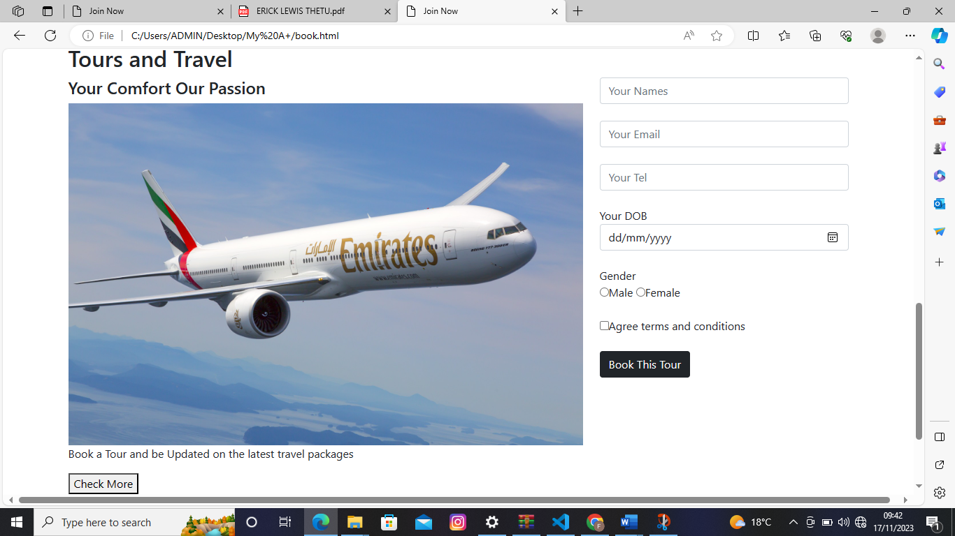

# CHAPTER FIVE: SUMMARY, CONCLUSION AND RECOMMENDATION

# 5.1 Objective

At the beginning of the project, I set out certain objectives which ought to be accomplished by the end of the system creation, at the end I was able to achieve most of the objectives set out.

# 5.1.1 Create a centralized database and integration framework.

The system consolidates travel information, ensuring a seamless and comprehensive view of itineraries and bookings.

# 5.1.2 Implement user-friendly comparison tools.

The system allows customers to easily compare travel options, including prices, services, and features, facilitating informed decision-making.

# 5.1.3 Establish a communication platform for real-time updates

The notifications, and interactions among travel agencies, service providers, and customers to minimize misunderstandings and disruptions through the contact page.

# 5.1.4 Design an intuitive trip planning interface

The system enables effortless arrangement of multi-destination trips or group tours, minimizing complexity and errors through viewing of trips.

# 5.2 Future Recommendations

# 5.2.1 Future Projects

The work that will be applied with future releases of the program will be to add more functionalities to the system, Enhance User Interface by adding more user interactive features, Provide Deals and promotional Offer details to home page. Provide Trips of the Week/Day to Home page, Add different payment options such as PayPal, Cash, Gift Cards etc. Allow to save payment details for future use.

# 5.3 Limitation

Several challenges were experienced in system development including development tools failing, limited time, power inconsistencies, internet connection challenges among many others

# 5.4 Conclusion

In conclusion, these findings represent the compass guiding us in the development and implementation of the Tours and Travel Management System. They provide the foundation for transformative change, laying the groundwork for an innovative solution in the travel and tourism industry.

**Reference**

[1] A. A. Mahrous and S. S. Hassan, “Achieving Superior Customer Experience: An Investigation of Multichannel Choices in the Travel and Tourism Industry of an Emerging Market,” *J. Travel Res.*, vol. 56, no. 8, 2017, doi: 10.1177/0047287516677166.

[2] M. Barna and B. Semak, “MAIN TRENDS OF MARKETING INNOVATIONS DEVELOPMENT OF INTERNATIONAL TOUR OPERATING,” *Balt. J. Econ. Stud.*, vol. 6, no. 5, 2020, doi: 10.30525/2256-0742/2020-6-5-33-41.

[3] N. Eltayeb, “Assessing the impact of mobile travel applications on tourism industries,” *Int. Acad. J. Fac. Tour. Hotel Manag.*, vol. 3, no. 3, 2017, doi: 10.21608/ijaf.2017.95545.

[4] P. Patil and V. L. Kolhe, “Survey of Travel Package Recommendation System,” *Int. J. Sci. Res. ISSN (Online Impact Factor*, vol. 3, no. 12, 2012.

[5] M. Mariani and R. Baggio, “Big data and analytics in hospitality and tourism: a systematic literature review,” *Int. J. Contemp. Hosp. Manag.*, vol. 34, no. 1, 2022, doi: 10.1108/IJCHM-03-2021-0301.

[6] M. Chiam, G. Soutar, and A. Yeo, “Online and off-line travel packages preferences: A conjoint analysis,” *Int. J. Tour. Res.*, vol. 11, no. 1, 2009, doi: 10.1002/jtr.679.

[7] R. K. Akamavi, F. Ibrahim, and R. Swaray, “Tourism and Troubles: Effects of Security Threats on the Global Travel and Tourism Industry Performance,” *J. Travel Res.*, 2022, doi: 10.1177/00472875221138792.

[8] B. Prideaux, “The role of the transport system in destination development,” *Tour. Manag.*, vol. 21, no. 1, 2000, doi: 10.1016/S0261-5177(99)00079-5.

# Appendix I

**Budgets**

|  |  |
| --- | --- |
| Description | Cost |
| Laptop(hp) | 35000 |
| Internet connection | 2000 |
| Printing | 300 |
| Flash drive | 1000 |
| TOTAL | 38300 |

# Appendix II

**Time schedule**

|  |  |  |  |  |  |  |  |  |  |
| --- | --- | --- | --- | --- | --- | --- | --- | --- | --- |
| No | Task | Duration | April | May | June | July | Sept | Oct | Nov |
| 1. | Proposal heading | 1 week |  |  |  |  |  |  |  |
| 2. | Approval of proposed project | 2 weeks |  |  |  |  |  |  |  |
| 3. | Writing and printing | 4 weeks |  |  |  |  |  |  |  |
| 4. | Approval of designed projects | 1 month |  |  |  |  |  |  |  |
| 5. | Presentation | day |  |  |  |  |  |  |  |
| 6. | Coding | 3 months |  |  |  |  |  |  |  |
| 7. | Presentation | day |  |  |  |  |  |  |  |

# Appendix III

